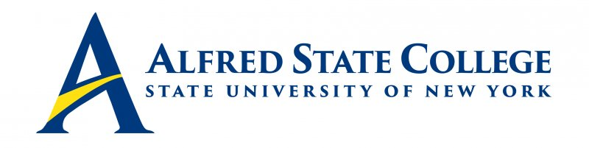

College Council Meeting

Thursday, February 10, 2022

5:00 pm Council Meeting

Lake Lodge

Agenda

- Call Meeting to Order-Chair Fogarty

- Minutes of Previous Meeting-Chair Fogarty

- College Council Chair’s Report-Chair Fogarty
- Welcome new council member Ms. Carrie Redman
- Welcome incoming president Dr. Steve Mauro

- President’s Updates -OIC Anderson

- Action Items
- Seeking Approval for Marketing BBA Program – C. Clark
- Seeking Approval for Proposed Parking Regulations Updates – G. Sammons
- Seeking Approval for Civic Engagement Award Nominations – G. Sammons

- Senior Staff Updates (Brief reports only!)
-Human Resources/CCET (Chief of Staff Dresser-Recktenwald)
-Student Affairs (Vice President Sammons)
-Enrollment Management (Vice President Penrose)
-Academic Affairs/Economic Development (Vice President Clark)
-Business Affairs (Chief Financial Officer Greenthal)
-Institutional Advancement (Executive Director White)

8. Constituency Reports
-Alumni Representative (Mr. Jack Benjamin)
-Faculty Representative (Mr. Matthew DiRado)
-Student Representative No report
-ACT Update (Mr. Ronald Nasca)

9. Unfinished Business

10. New Business

Strategic Priority #5 Student Development and Support
Civic Engagement Award Nominations

Strategic Priority #1 Advanced Hands-on Learning

Strategic Priority #2 Inclusion and Belonging

Strategic Priority #3 Team Investment and Professional Growth

Strategic Priority #4 Partnership and Impact

Strategic Priority #5 Student Development and Support

Strategic Priority #6 Campus Renewal and Resource Optimization

Strategic Priority #7 Enrollment and Recruitment

