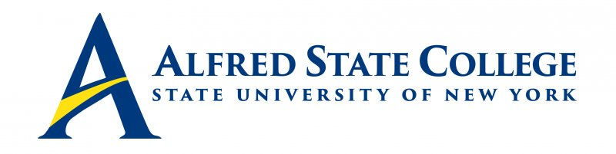

College Council Meeting

Monday, Sept. 22, 2025

5:30pm Council Meeting

Lake Lodge, Alfred NY

Agenda

- Call Meeting to Order-Ron Nasca

- Minutes of Previous Meeting for Approval -Ron Nasca

- College Council Chair’s Report- Ron Nasca
- Welcome our new student representative – Zeniya Day

- President’s College Update – President Mauro

- Senior Staff Updates (Brief reports only!)
- Human Resources & Student Affairs (VP Sammons)
- Enrollment Management (VP Zuber)
- Academic Affairs (VP Cokely)
- Institutional Advancement (VP White)
- Business Affairs (VP LaBrozzi)

8. Constituency Reports
- Alumni Representative (Mr. Jack Benjamin)
- Faculty Representative (Ms. Ruthanne Ashworth)
- Student Representative (Zeniya Day)
- ACT Update (Mr. Ronald Nasca)

9. Unfinished Business

10. New Business

11. Adjourn Meeting

