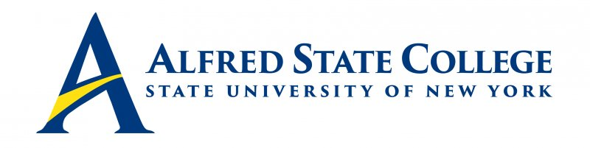

College Council Meeting

Monday, February 8, 2021

5:30 pm Council Meeting

TEAMS

Agenda

- Call Meeting to Order-Chair Fogarty

- Minutes of Previous Meeting-Chair Fogarty

- College Council Chair’s Report-Chair Fogarty
- Presidential Search Update

- President’s Updates/Institutional Advancement Report-President Sullivan

- Action Items
- Leadership Through Civic Engagement, Student Nominees – Vote
  - Ruth Crowley
  - Alec Harrigan
  - Alexa Sass

- Senior Staff Updates (Brief reports only!)
-Human Resources/CCET (Chief of Staff Dresser-Recktenwald)
-Student Affairs (Vice President Sammons)
-Economic Development (Vice President Clark)
-Enrollment Management (Vice President Penrose)
-Academic Affairs (Provost Poppo)
-Business Affairs (Chief Financial Officer Greenthal)

8. Constituency Reports
-Alumni Representative (Mr. Jack Benjamin)
-Faculty Representative (Mr. Michael Colomaio)
-Student Representative (Baylee Durantini)
-ACT Update (Mr. Ronald Nasca)

9. Unfinished Business

10. New Business

Strategic Priority Goal: #5 Student Development and Support
Leadership Through Civic Engagement, Student Nominees – Vote

Strategic Priority #1 Advanced Hands-on Learning

Strategic Priority #2 Inclusion and Belonging

Strategic Priority #3 Team Investment and Professional Growth

Strategic Priority #4 Partnership and Impact

Strategic Priority #5 Student Development and Support

Strategic Priority #6 Campus Renewal and Resource Optimization

Strategic Priority #7 Enrollment and Recruitment

