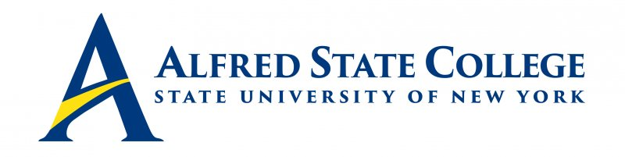

College Council Meeting

Monday, February 6, 2023

5:00 pm Council Meeting

Lake Lodge

Agenda

- Call Meeting to Order-Chair Fogarty

- Minutes of Previous Meeting for Approval -Chair Fogarty

- Introduction of Middle States Chairs – Dr. Mauro

- College Council Chair’s Report-Chair Fogarty

- President’s Updates – President Mauro

- Executive Session

- Action Items
- Approval of Civic Engagement Award Nominees – Presented by VP Sammons

- Senior Staff Updates (Brief reports only!)
-Human Resources/CCET & Student Affairs (Vice President Sammons)
-Enrollment Management (AVP Geibel)
-Academic Affairs/Economic Development (Vice President Clark)
-Institutional Advancement (VP White)
-Business Affairs (VP Sortore)

8. Constituency Reports
-Alumni Representative (Mr. Jack Benjamin)
-Faculty Representative (Mr. Matthew DiRado)
-Student Representative (Soumya Konar)
-ACT Update (Mr. Ronald Nasca)

9. Unfinished Business

10. New Business

