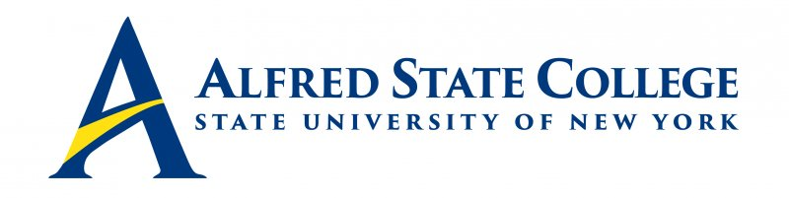

College Council Meeting

Monday, April 10, 2023

5:30 pm Council Meeting

Lake Lodge

Agenda

- Call Meeting to Order-Chair Fogarty

- Minutes of Previous Meeting for Approval -Chair Fogarty

- Introduction of Middle States Chairs – Dr. Mauro

- College Council Chair’s Report-Chair Fogarty

- President’s Updates – President Mauro

- Senior Staff Updates (Brief reports only!)
- Human Resources/CCET & Student Affairs (Vice President Sammons)
- Enrollment Management (VP Penrose)
- Academic Affairs/Economic Development (Vice President Clark)
- Institutional Advancement (VP White)
- Business Affairs (VP Sortore)

8. Constituency Reports
- Alumni Representative (Mr. Jack Benjamin)
- Faculty Representative (Mr. Matthew DiRado)
- Student Representative (Soumya Konar)
- ACT Update (Mr. Ronald Nasca)

9. Unfinished Business

10. New Business

11. Dinner presentations:
- Alfred Downtown Revitalization – Architecture students
- Disaster Relief Florida trip – Civic engagement students

